# Meeting Information

|  |  |
| --- | --- |
| Meeting Name: | Information Modeling Project/FHIM Meeting |
| Date & Time: | May 1, 2015 |
| Location: | Online |

# Attendance

| Name | Organization | Attendance  (In person/Online) |
| --- | --- | --- |
| Steve Wagner | FHA | Online |
| Galen Mulrooney | FHA | Online |
| Bill Hess | FDA | Online |
| David Bass | VA | Online |
| Iona Thraen | Utah Dept. of Health | Online |
| Jay Lyle | FHA | Online |
| John Weiser | DoD | Online |
| Elizabeth McCool | VA | Online |
| Raisa Ionin | DoD | Online |
| Kenneth Salyards | SAMHSA | Online |
| Steve Hufnagel | DoD | Online |
| Susan Campbell |  | Online |
| Susan Matney | DoD | Online |
| Håkan Lidström | FHA | Online |

# Meeting Summary

## Update on S&I and FHA Initiatives, Etc. (*Steve Wagner*)

No S&I activities this week.

Review packages for FHIM domains Allergies, Health Concern and Vital Signs were sent out on April 27. The review period runs until June 26.

Susan Matney gave an informal report from the recent IHTSDO meeting in Denmark. All technical committees are resolved. The IHTSDO headquarters is moving to the United Kingdom. Some basic SNOMED training is now available for free, there are multiple webinars + tests.

## Terminology Modeling Update (*Jay Lyle*)

The group has reviewed and updated the terminology modeling principles. There will be a break in the meeting schedule during the HL7 meeting. Next terminology meeting will be on May 20, when Care Plan modeling will begin.

## Modeling of Radiology and Imaging Domains (*Galen Mulrooney*)

Galen apologized for not doing much in the last week (due to HL7 ballot related tasks). However, the general approach for the modeling was discussed. Partners are reminded to send whatever relevant material they may have as input to this work.

It was reconfirmed that the current classes in the FHIM Imaging and Radiology domains are too much a reflection of legacy VistA implementations and that the approach used in FHIR is much cleaner and subject matter oriented. See figure below)

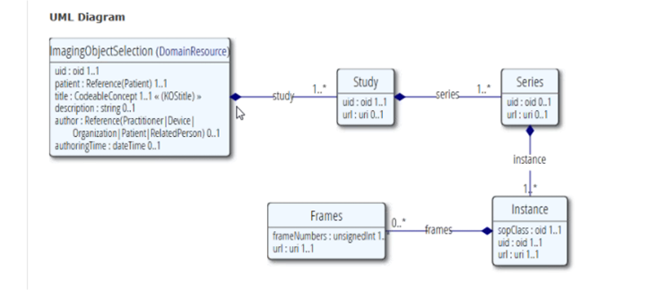

It was also agreed that there is no need to separate Radiology and Imaging in two domains in FHIM. Though, FHIM must make a clear distinction between “diagnostic quality” and other types of images.

Galen will use merge Radiology and Imaging into one domain and will use the FHIR resources above as a pattern for the core classes. Other classes will be added to cover aspects that are not in FHIR.

The IM group will continue to meet during the HL7 session.

# Next Meeting

Friday, May 81, 2015 at 2:30 PM, EDT

# Action Items

| Action Item Description | Responsible | Due Date |
| --- | --- | --- |
| Bring relevant models as input to the Radiology and Imaging work | All partner agencies | May 8 |
| Merge Radiology and Imaging domains. Refactor with FHIRE as a pattern for core classes. | FHA Team | May 8 |

# FHIM Information and Terminology Modeling Calls

## Information Modeling (IM) project calls (Every Friday)

Time of Calls: 2:30 to 4:30 PM Eastern Time  
<https://global.gotomeeting.com/join/947006365>  
Use your microphone and speakers (VoIP) - a headset is recommended.  
Or, call in using your telephone.  
Dial +1 (646) 749-3131  
Access Code: 947-006-365  
Audio PIN: Shown after joining the meeting.

## Terminology Modeling calls (Every Wednesday)

**The next Terminology call will be on May 20.**

Time of Calls: 2:00 to 3:30 PM Eastern Time  
<https://global.gotomeeting.com/join/947006365>  
Use your microphone and speakers (VoIP) - a headset is recommended.  
Or, call in using your telephone.  
Dial +1 (646) 749-3131  
Access Code: 947-006-365  
Audio PIN: Shown after joining the meeting.

## FHA Health Information Modeling WG (2’nd Tuesday each month)

Next meeting: May 12 at 1 PM Eastern Time

Time of Calls: 1:00 to 2:00 PM Eastern Time  
<https://www3.gotomeeting.com/register/267621646>

Use your telephone for audio.  
Dial + 1-888-537-7715 Code: 2734 4310#